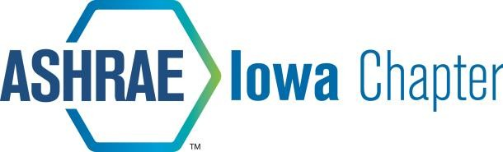

ASHRAE IOWA CHAPTER SCHOLARSHIP PROGRAM

The ASHRAE Iowa Chapter will be awarding three to five scholarships this year with a minimum amount of $1000.00 each. $5000 total is available in the scholarship pool. The number of scholarships and dollar amount of the scholarships will be based on the quality of the applicants. Scholarship applicants must meet the following requirements:

- Applicant must be enrolled in a Mechanical Engineering or Construction Engineering program with Mechanical Emphasis at Iowa State University.

- Applicant can be a graduate student or an undergraduate student.

Applicants will be scored based on the following criteria:

Involvement in ISU ASHRAE Chapter | 20 points
Interest in HVAC related fields | 20 points
Scholastic Achievement | 30 points
Financial Need | 30 points

Sign up to become a student member at https://join.ashrae.org/
ASHRAE Iowa Chapter will reimburse the membership fee for all student members that attend one ASHRAE Iowa Chapter meeting.

Judging will be done by a panel of ASHRAE Iowa Chapter members.

Application must be submitted to Mike Wolfe at wolfem@thebakergroup.com by 11:00 PM, Wednesday, November 6th, 2019.

Recipients of the scholarships will be notified Tuesday, November 12th.

Presentation of the scholarships will be made at the November 19th evening meeting of the ASHRAE Iowa Chapter, to be held in Ames.

