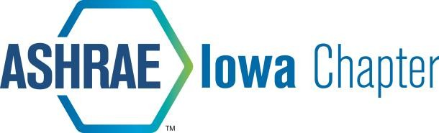

2020 - ASHRAE IOWA CHAPTER SCHOLARSHIP PROGRAM

The ASHRAE Iowa Chapter will be awarding up to five scholarships this year with a minimum amount of $1,000.00 per scholarship. $5,000 is available in the scholarship pool. The number of scholarships and dollar amount of the scholarships will be based on the quality of the applicants. Scholarship applicants must meet the following requirements:

- Applicant must be enrolled in a Mechanical Engineering or Construction Engineering program with Mechanical Emphasis at Iowa State University.

- Applicant can be a graduate student or an undergraduate student.

Applicants will be scored based on the following criteria:

Involvement in ISU ASHRAE Chapter | 20 points
Interest in HVAC related fields | 20 points
Scholastic Achievement | 30 points
Financial Need | 30 points

Sign up to become a student member at https://join.ashrae.org/
ASHRAE Iowa Chapter will reimburse the membership fee for all student members that attend one ASHRAE Iowa Chapter meeting.

Judging will be done by a panel of ASHRAE Iowa Chapter members.

Applications must be submitted to Joe Nielsen at Nielsenj@thebakergroup.com by 11:00 PM on Thursday, October 8th.

Recipients of the scholarships will be notified Thursday, October 15th.

Presentation of the scholarships will be made at the October 22nd evening meeting of the ASHRAE Iowa Chapter. If the meeting is held in Ames, checks will be distributed that evening. If the meeting is virtual, checks will be mailed to recipients following the meeting.

